Your practice/clinic may have a section on your website that explains some of the treatment options you offer for chronic pain. You can use this template text to show that you offer the latest in spinal cord stimulation technology.

Spinal Cord Stimulation (SCS)

If you’ve been suffering from chronic pain and have tried other treatment options with limited success, you may be a candidate for spinal cord stimulation – a safe, non-drug therapy option.

What is spinal cord stimulation?

We feel pain when our bodies send a signal to the brain. Spinal cord stimulation (SCS) is a non-drug, non-opioid option for treating chronic pain that has been proven safe and effective for more than 50 years. A small device, called a neurostimulator, is implanted minimally invasively and connected to thin wires, called leads, which send mild pulses of energy to the spinal cord to interrupt pain signals before you feel them.

Practice XYZ is one of the first in the country to offer the latest in spinal cord stimulation technology, the Evoke® System.
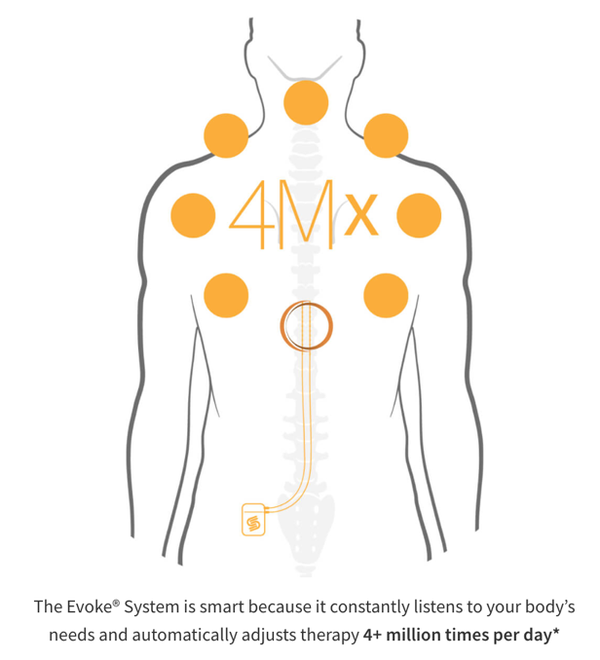
How does it work?

The Evoke System is comprised of a small device that safely works inside your body to provide lasting pain relief and restore your quality of life.^{1,2}

Like a smart thermostat that maintains the preferred temperature, Evoke listens to your body’s individual needs and automatically adjusts therapy in real time so you can focus less on your pain and more on living your life.

The Evoke System is backed by the most enduring patient outcomes out to 36 months from the EVOKE Study, the only double-blind, randomized pivotal clinical study in the history of SCS. The 36-month data was presented by Nagy Mekhail, MD, PhD, Professor of Anesthesiology, Carl Wasmuth Chair and Director, Evidence-Based Pain Management Research at the Cleveland Clinic during the Late-Breaking Clinical Abstracts Session at the North American Neuromodulation Society (NANS) meeting in January 2023³.
- Implanted closed loop patient outcomes:
  - 83% of patients had ≥50% VAS Reduction
  - 59% of patients had ≥80% VAS Reduction
  - 0 explants due to loss of efficacy
- While patients were blinded to what therapy they were receiving, when allowed to cross over at 24 months, 9 out of 10 patients stayed in SmartLoop™ therapy
- Beyond pain relief, patients experienced multidimensional improvements in patients' quality of life, functional status, mood and sleep

Speak to your doctor to understand the potential benefits and risks of SCS. All patients do not respond the same way and experiences may vary.

What Should I Expect?

One of the advantages of SCS is that you can try the therapy to see if it works for you.

- Step 1: SCS Therapy Evaluation
Everyone experiences pain differently. Your doctor will evaluate you to determine if SCS might help to address your chronic pain based upon your unique needs.

- Step 2: Trial Period
If your doctor recommends moving forward, you’ll be able to trial the therapy with a temporary system. Your doctor will place temporary ‘wires with electrodes’ under your skin along your spine and you will be given a temporary external pulse generator that you will wear outside of your body.

- Step 3: Implant
After the trial, you and your doctor will meet to talk about your experience with Evoke. If the therapy is providing you with good pain relief and is helping you to return to normal daily activities, your doctor will discuss with you about proceeding to a minimally invasive outpatient procedure for the implant. Only the Evoke System can listen to your body's needs and automatically adjust therapy 4+ million times a day, delivering lasting pain relief.

Frequently Asked Questions

- Will my insurance cover the costs related to the trial and permanent implant?
  - You should confirm coverages with your insurance company and doctor’s office. However, while not guaranteed, costs associated with the trial and implant are typically covered by major insurance companies, Medicare, and Workers’ Compensation.
- What is the recovery period for the implant?
  - Though minimally invasive, you will need to take it easy for six to eight weeks as your body heals. It’s important to follow your specific recovery instructions and check with your doctor before increasing physical activity.
- How will my doctor monitor my therapy?
  - You will have regular follow-up visits with your doctor to ensure your therapy is working well for you, including monitoring your therapy and adjusting as necessary.

Is SCS right for me?

To learn more or to schedule an appointment, visit XXX [link to practice appointment scheduling page]

*The Evoke® System takes measurements and adjusts stimulation output at each and every stimulation pulse delivered. On average, the Evoke® System’s SmartLoop™ therapy makes 4+ million measurements and adjustments per day depending on each patient’s unique needs.

1. At 24 months: Mekhail N, Levy RM, Deer TR, et al. Durability of clinical and quality-of-life outcomes of closed-loop spinal cord stimulation for chronic back and leg pain: a secondary analysis of the Evoke randomized clinical trial. JAMA Neurol. 2022;79(3):251-260.

2. Falowski S, et al. Treating the chronic pain cycle using ECAP-controlled closed-loop spinal cord stimulation: 24-month EVOKE Study results. Presented at: American Society of Pain and Neuroscience (ASPN) Innovation Summit; July 14-17, 2022; Miami, FL.

3. NANS 2023 presentation, N. Mekhail; EVOKE Study 36-month Data on File

Risks and Important Safety Info: www.saludamedical.com/safety
Rx Only
In the US, the Saluda Medical Evoke® SCS System is indicated as an aid in the management of chronic intractable pain of the trunk and/or limbs.

